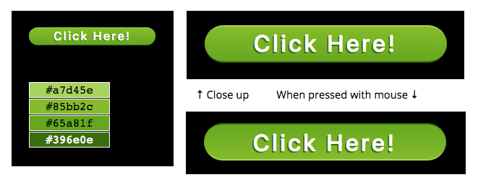

Give the students the above image. Have them make it with CSS from a button.

One point for each…

white text

green background

gradient background

rounded corners

left-right padding

top-bottom padding

top & bottom highlights

gradient reversed on press

highlights reversed on press

Shadow on text (1/2 wrong color)

letter spacing (bonus)